1. In shell scripting, we can write commands sequentially.
2. cat /etc/shells 🡪 to check shells present in server.
3. Shebang value of bash is coming from,



1. **Example of builtin, keyword & command.**

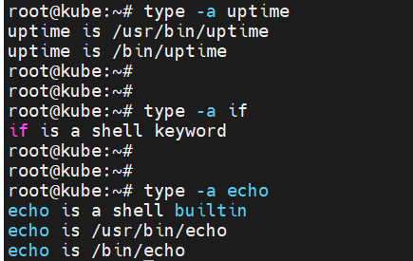

1. Server will search command in path & then execute it so its quite time consuming. Try to use built-in in your script as much as possible for fast execution since built-in run faster than commands.



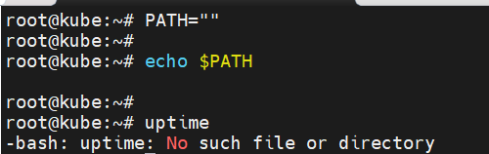

1. Syntax to print messages in different color.

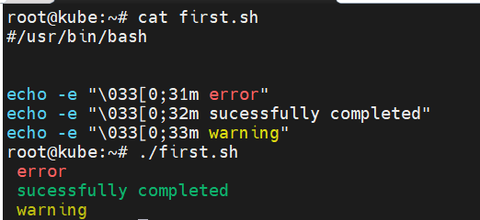

1. Back slash ‘\’ is used to define the continuation of data.

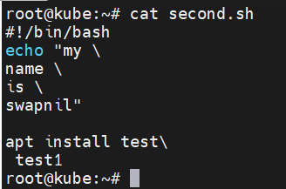

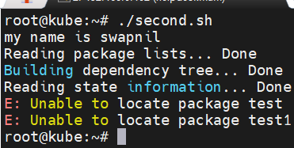

1. **Single inverted comma ‘ means strong quote. i.e. print as it is.**

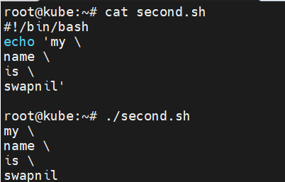

1. \t 🡪 for tab space

\v 🡪 vertical tab space

\n 🡪 for new line

